* .

INSTITUTE OF ENGINEERING & MANAGEMENT



**PHOTO GALLERY**

**VERSION 1.0**

Presented By

Manish Kumar Gupta

Under guidance of :

IEM INDUSTRIAL TRANNING

S

C

E

I

M

E

2015

Acknowledgement

I present herewith pride & pleasure the work of **“Photo Gallery”** with the help of **‘ASP DOT NET’** aimed to supplement the scholastic attainment as required under the regulation of West Bengal University of Technology (WBUT).

Life of human being is full of interaction. No one is a self-sufficient by himself. In our daily life we go ahead by acquiring something from each other. Whenever anyone is doing serious and important work, where a lot of help and guidance from many people concerned is required, one feels obliged to them. The guidance and cooperation during the project work has left a long impression in our mind and while giving the final shape to our project report. I would like to take a minute to acknowledge those who made this project possible for me.

**IEM Industrial Tanning from College**, without his timely co-operation and valuable guidance the completion of this project would have been a difficult task.

All faculty members of CSE department who provide their valuable suggestion & knowledge regarding the project.

**ABSTRACT**

This project is all about an online registration system of the customers who visit this webpage. So here any customer can login if they create an account here & they can also check out different aspects.

If they are interested, then they can fill-in the provided form & get registered.

CONTENTS

**CHAPTER: I**

01. INTRODUCTION

02. OBJECTIVES

03. ABOUT THE PROJECT

(A) PROJECT IN BRIEF

(B) PROJECT IN DETAIL

04. FEASIBILITY ANALYSIS

(A) Technical Feasibility

(B) Economical Feasibility

**CHAPTER: II**

05. SYSTEM IMPLEMENTATION

06. PLATFORM USE

(A)HARDWARE USE

(B)SOFTWARE USE

**CHAPTER: III**

07. DATA FLOW DIAGRAM

08. ER - DIAGRAM

**CHAPTER: IV**

**09. CODING**

(A) **Default.aspx**

(B) **Default.aspx.cs**

**(C) register.aspx**

(d) **register.aspx.cs**

(e) **register.css**

**(F) common.css**

(G) **cat1.aspx**

(H) **cat1.aspx.cs**

**(I) cat2.aspx**

(J) **cat2.aspx.cs**

(K) **cat3.aspx**

**(L) cat1.aspx.cs**

(M) **cat4.aspx**

(N) **cat4.aspx.cs**

**(O) fullsize.aspx**

(P) **fullsize.aspx.cs**

**CHAPTER: V**

10. SCREEN SHORTS

(A)Register Page

(B)Login Page

(C)Welcome Page

(D)Home Page

(E)User Login Database

(F)Image Database

**CHAPTER: VI**

11. Conclusion

(A)Further Scope

(B)System Testing & Maintenance

(C)Enhancement scope

(D)Conclusion

Bibliography

**CHAPTER: I**

1. **Introduction**

The main purpose of a photo gallery is to link other web sites by categorizing them into different sections. Sort of like an online filling cabinet, but the sites do not necessarily have to be in alphabetical order, but majority of web directories have their categories and topics in alphabetical order, but it is not a must.

The software is for online registration of any customer.

For example, if you’re performing an online search for some species, you would search under the wildlife link or tab, depending on the site. If you interested to view some special photo like nature, places etc you can select different category according to your choice. Photo Gallery are there to help you online, they are basically a helping aide or a tool to help you find your way online for some special picture captured by special talented photographer.

1. Objectives

In our modern era of organization of web development it is very important to keep the data and image into an organized manner so that when requited it could be fetched out from the location. This organization of data is done by using various ways.

In this project the goal is to development an efficient and user friendly basic website to take different category images to save and retrieve when required.

The overall scope of this project is to develop a basic website which is better or effective as per as complexity and also user friendly.

1. **About The Project**

This Project has been created by the student of **4th Year** **B.Tech in Computer Science & Engineering** as a part of my final year summer training project.

This project has been created by **Manish Kumar Gupta** working under guidance of **IEM Industrial Training** **Group** in college on **Photo Gallery** website.

My aim is to study and understand the different technology and aspect of ASP DOT NET. The overall objective is to understand and make a photo gallery website.

1. **Project In Brief**

There will be some major components:

* Viewer registration process.
* Viewer login process.

Proposed system provides with following solutions to the manual process:

* It provides better and efficient service.
* Reduce the workload of the stuffs.
* Provide facility for proper monitoring, reduce paper works & provide data security.

1. **Project In Detail**

**Area**:- Online Photo Viewer

**Software Name**:- Photo Gallery

**Responsibility**:- Project development, testing and Implementation

**Front End**:- ASP DOT NET.

**Back End**:- Microsoft SqlServer.

**Project type**:- Web Based Project.

**Under By** :-IEM Industrial Training Group

1. **Feasibility Analysis**

Whatever we think need not be feasible. It is wise to think about the feasibility of any problem we undertake. Feasibility is the study of impact, which happens in the organization by the development of a system. The impact can be either positive or negative. When the positive dominates the negatives then the system is considered is feasible. Here the feasible study can be performed in two ways such as Technical Feasibility and Economical Feasibility.

1. **Technical Feasibility**

We can strongly say that it is technically feasible, since there will not be much difficulty in getting required resources for the development and maintaining the system as well. All the resources needed for the development of the software as well as the same is available in the organization itself.

1. **Economical Feasibility**

Development of this application is highly economically feasible. The organization needed not spend much money for the development of the system already available. The only thing is to be done is making an environment for the development with an effective supervision. If we are doing so, we can attain the maximum usability of the corresponding resources. Even after the development, the organization will not be in a condition to invest more in the organization. Therefore, the system is economically feasible.

**CHAPTER: II**

1. **System** Implementation

The systems implementation is a process of construction and delivery phases of the life cycle. Systems implementation is the construction of the new system and the delivery of that system into production.

Stages Of Implementation Area

1. Analysis of the project
2. GUI Design
3. Coding (Individual testing method)
4. Database Design.
5. Testing
6. System testing
7. System maintenance.
8. **Platform U**se
9. **Hardware Use**

* Processor ( Intel, AMD minimum 1 GHz speed )
* Hard Disk (minimum 7 GB free space)
* RAM ( 512 MB or more )
* Video memory( minimum 16MB )
* Keyboard

1. **Software Use**

* Operating System – Windows 7 or higher version.
* Visual Studio 2012.

**CHAPTER: III**

* **07.DATA FLOW DIAGRAM**

1. **DFD: LEVEL 0**

**REGISTRATION**

**USER**

**HOME**

**LOGIN**

**HOME**

1. **DFD: LEVEL 1**

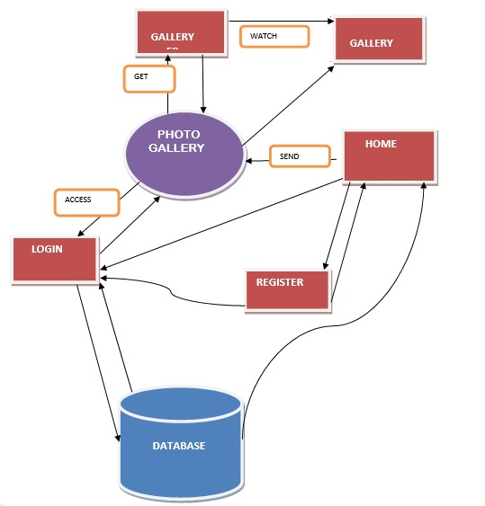

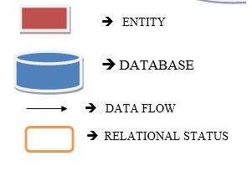

**08. ER - DIAGRAM**

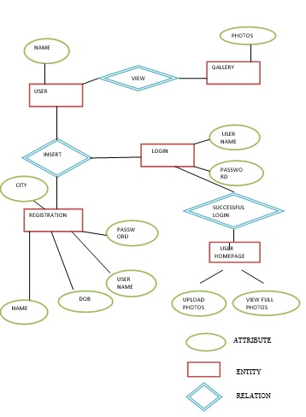

**CHAPTER: IV**

**09. Coding**

1. Default.aspx

<%@ Page Language="C#" AutoEventWireup="true" CodeBehind="default.aspx.cs" Inherits="Photo_Gallery.WebForm1" %>

<!DOCTYPE html>

<link rel="stylesheet" type="text/css" href="register.css">

<html xmlns="http://www.w3.org/1999/xhtml">

<head runat="server">

<title>Sign In</title>

</head>

<body>

<form id="form1" runat="server">

<div style="height:500px">

<table class="page">

<tr class ="header">

<td colspan="2">

<img alt="Logo" class="auto-style6" src="images/Logo.png" style="padding-top:10px" /></td>

</tr>

<tr>

<td class="content-left">

</td>

<td class="content-right">

<table>

<tr>

<asp:Label ID="SignINLabel" runat="server" Text="Sign IN" Font-Bold="True" Font-Names="Corbel" Font-Size="X-Large"></asp:Label>

</tr>

<hr />

<tr>

<td class="auto-style5" colspan="2">

&nbsp;</td>

</tr>

<tr>

<td class="auto-style5">

<asp:Label ID="UNLabel" runat="server" Text="UserName" Font-Bold="True" Font-Names="Constantia"></asp:Label>

</td>

<td>

<asp:textbox id="UN" type="text" runat="server" ></asp:textbox></td>

</tr>

<tr>

<td class="auto-style5">

<asp:Label ID="PasswordLabel" runat="server" Text="Password" Font-Bold="True" Font-Names="Constantia"></asp:Label>

</td>

<td>

<asp:textbox id="Password" type="password" runat="server" ></asp:textbox></td>

</tr>

<tr>

<td class="auto-style5">

&nbsp;</td>

<td style="text-align: right ; padding-top:10px;">

<asp:Label ID="msg" runat="server" Text="UserName or Password Incorrect" Font-Bold="False" Font-Names="Comic Sans MS" ForeColor="Red" Visible="False"></asp:Label>

<br />

<asp:Button ID="Button1" runat="server" OnClick="Button1_Click" Text="Submit" BackColor="#00CC00" BorderColor="Black" BorderStyle="Outset" Font-Bold="False" Font-Names="Bookman Old Style" Font-Overline="False" Font-Size="Medium" />

</td>

</tr>

<tr>

<td class="auto-style5">

&nbsp;</td>

<td style="text-align: right ; padding-top:10px;">

<asp:DynamicHyperLink ID="DynamicHyperLink1" runat="server" Font-Names="Comic Sans MS" NavigateUrl="~/register.aspx">Don&#39;t have an account? Create One..</asp:DynamicHyperLink>

</td>

</tr>

</table>

</td>

</tr>

<tr class="footer">

<td colspan="2"></td>

</tr>

</table>

</div>

</form>

</body>

</html>

1. Default.aspx.cs

using System;

using System.Collections.Generic;

using System.Linq;

using System.Web;

using System.Web.UI;

using System.Web.UI.WebControls;

//using System.Data.Sql;

using System.Data.SqlClient;

namespace Photo_Gallery

{

public partial class WebForm1 : System.Web.UI.Page

{

public static SqlConnection con = new SqlConnection(@"Data Source=(LocalDB)\v11.0;AttachDbFilename=C:\Users\ManishKumar\Documents\Visual Studio 2012\Projects\Photo Gallery\Photo Gallery\App_Data\Database1.mdf;Integrated Security=True");

SqlCommand cmd = new SqlCommand();

SqlDataReader dr;

protected void Page_Load(object sender, EventArgs e)

{

Session["UserName"] = "";

}

protected void Button1_Click(object sender, EventArgs e)

{

string UName = UN.Text;

string pwd = Password.Text;

string userexists = "0";

cmd.Connection = con;

con.Open();

cmd.CommandText = "select COUNT(*) AS Count from UserData where UN='" + UName + "' AND Pwd = '" + pwd + "'";

cmd.ExecuteNonQuery();

dr = cmd.ExecuteReader();

while (dr.Read())

{

userexists = dr["Count"].ToString();

}

dr.Close();

if (userexists == "0")

{

msg.Visible = true;

con.Close();

}

else

{

msg.Visible = false;

Session["UserName"] = UName;

con.Close();

Response.Redirect("~/cat1.aspx");

}

}

}

}

1. register.aspx

<%@ Page Language="C#" AutoEventWireup="true" CodeBehind="register.aspx.cs" Inherits="Photo_Gallery.register" %>

<!DOCTYPE html>

<link rel="stylesheet" type="text/css" href="register.css">

<html xmlns="http://www.w3.org/1999/xhtml">

<head runat="server">

<title>SignUP</title>

<style type="text/css">

.auto-style6 {

width: 218px;

height: 56px;

}

</style>

</head>

<body>

<form id="form1" runat="server">

<div>

<table class="page">

<tr class ="header">

<td colspan="2">

<img alt="Logo" class="auto-style6" src="images/Logo.png" style="padding-top:10px" /></td>

</tr>

<tr>

<td class="content-left">

</td>

<td class="content-right">

<table>

<tr>

<asp:Label ID="SignUpLabel" runat="server" Text="Sign UP" Font-Bold="True" Font-Names="Corbel" Font-Size="X-Large"></asp:Label>

</tr>

<hr />

<tr>

<td class="auto-style5">

<asp:Label ID="FNLabel" runat="server" Text="First Name" Font-Bold="True" Font-Names="Constantia"></asp:Label>

</td>

<td>

<asp:textbox id="FN" type="text" runat="server" ></asp:textbox></td>

</tr>

<tr>

<td class="auto-style5">

<asp:Label ID="LNLabel" runat="server" Text="Last Name" Font-Bold="True" Font-Names="Constantia"></asp:Label>

</td>

<td>

<asp:textbox id="LN" type="text" runat="server" ></asp:textbox></td>

</tr>

<tr>

<td class="auto-style5">

<asp:Label ID="UNLabel" runat="server" Text="UserName" Font-Bold="True" Font-Names="Constantia"></asp:Label>

</td>

<td>

<asp:textbox id="UN" type="text" runat="server" ></asp:textbox></td>

</tr>

<tr>

<td class="auto-style5">

<asp:Label ID="PasswordLabel" runat="server" Text="Password" Font-Bold="True" Font-Names="Constantia"></asp:Label>

</td>

<td>

<asp:textbox id="Password" type="password" runat="server" ></asp:textbox></td>

</tr>

<tr>

<td class="auto-style5">

<asp:Label ID="MobileLabel" runat="server" Text="Mobile" Font-Bold="True" Font-Names="Constantia"></asp:Label>

</td>

<td>

<asp:textbox id="Mobile" type="text" runat="server"></asp:textbox></td>

</tr>

<tr>

<td class="auto-style5">

<asp:Label ID="DOBLabel" runat="server" Text="DOB" Font-Bold="True" Font-Names="Constantia"></asp:Label>

</td>

<td>

<asp:DropDownList ID="Day" runat="server" Height="28px" OnSelectedIndexChanged="DropDownList1_SelectedIndexChanged" Width="100px">

<asp:ListItem>Day</asp:ListItem>

<asp:ListItem>1</asp:ListItem>

<asp:ListItem>2</asp:ListItem>

<asp:ListItem>3</asp:ListItem>

<asp:ListItem>4</asp:ListItem>

<asp:ListItem>5</asp:ListItem>

<asp:ListItem>6</asp:ListItem>

<asp:ListItem>7</asp:ListItem>

<asp:ListItem>8</asp:ListItem>

<asp:ListItem>9</asp:ListItem>

<asp:ListItem>10</asp:ListItem>

<asp:ListItem>11</asp:ListItem>

<asp:ListItem>12</asp:ListItem>

<asp:ListItem>13</asp:ListItem>

<asp:ListItem>15</asp:ListItem>

<asp:ListItem>16</asp:ListItem>

<asp:ListItem>17</asp:ListItem>

<asp:ListItem>18</asp:ListItem>

<asp:ListItem>19</asp:ListItem>

<asp:ListItem>20</asp:ListItem>

<asp:ListItem>21</asp:ListItem>

<asp:ListItem>22</asp:ListItem>

<asp:ListItem>23</asp:ListItem>

<asp:ListItem>24</asp:ListItem>

<asp:ListItem>25</asp:ListItem>

<asp:ListItem>26</asp:ListItem>

<asp:ListItem>27</asp:ListItem>

<asp:ListItem>28</asp:ListItem>

<asp:ListItem>29</asp:ListItem>

<asp:ListItem>30</asp:ListItem>

<asp:ListItem>31</asp:ListItem>

</asp:DropDownList>

<asp:DropDownList ID="Month" runat="server" Height="28px" Width="100px" OnSelectedIndexChanged="Month_SelectedIndexChanged">

<asp:ListItem>Month</asp:ListItem>

<asp:ListItem>1</asp:ListItem>

<asp:ListItem>2</asp:ListItem>

<asp:ListItem>3</asp:ListItem>

<asp:ListItem>4</asp:ListItem>

<asp:ListItem>5</asp:ListItem>

<asp:ListItem>6</asp:ListItem>

<asp:ListItem>7</asp:ListItem>

<asp:ListItem>8</asp:ListItem>

<asp:ListItem>9</asp:ListItem>

<asp:ListItem>10</asp:ListItem>

<asp:ListItem>11</asp:ListItem>

<asp:ListItem>12</asp:ListItem>

</asp:DropDownList>

<asp:DropDownList ID="Year" runat="server" Height="28px" OnSelectedIndexChanged="DropDownList3_SelectedIndexChanged" style="margin-bottom: 0px" Width="100px">

<asp:ListItem>Year</asp:ListItem>

<asp:ListItem>2000</asp:ListItem>

<asp:ListItem>1999</asp:ListItem>

<asp:ListItem>1998</asp:ListItem>

<asp:ListItem>1997</asp:ListItem>

<asp:ListItem>1996</asp:ListItem>

<asp:ListItem>1995</asp:ListItem>

<asp:ListItem>1994</asp:ListItem>

<asp:ListItem>1993</asp:ListItem>

<asp:ListItem>1992</asp:ListItem>

<asp:ListItem>1991</asp:ListItem>

<asp:ListItem>1990</asp:ListItem>

<asp:ListItem>1989</asp:ListItem>

<asp:ListItem>1988</asp:ListItem>

<asp:ListItem>1987</asp:ListItem>

</asp:DropDownList>

</td>

</tr>

<tr>

<td class="auto-style5">

&nbsp;</td>

<td style="text-align: right ; padding-top:10px">

<asp:Button ID="Button1" runat="server" OnClick="Button1_Click" Text="Submit" BackColor="#00CC00" BorderColor="Black" BorderStyle="Outset" Font-Bold="False" Font-Names="Bookman Old Style" Font-Overline="False" Font-Size="Medium" />

</td>

</tr>

<tr>

<td class="auto-style5">

&nbsp;</td>

<td style="text-align: right ; padding-top:10px">

<asp:DynamicHyperLink ID="DynamicHyperLink1" runat="server" Font-Names="Comic Sans MS" NavigateUrl="~/default.aspx">Already Have an account. LogIn Here..</asp:DynamicHyperLink>

</td>

</tr>

</table>

</td>

</tr>

<tr class="footer">

<td colspan="2"></td>

</tr>

</table>

</div>

</form>

</body>

</html>

1. register.aspx.cs

using System;

using System.Collections.Generic;

using System.Linq;

using System.Web;

using System.Web.UI;

using System.Web.UI.WebControls;

using System.Data.SqlClient;

//using System.Data;

//using System.Data.OleDb;

//using System.Text;

namespace Photo_Gallery

{

public partial class register : System.Web.UI.Page

{

public static SqlConnection con = new SqlConnection(@"Data Source=(LocalDB)\v11.0;AttachDbFilename=C:\Users\ManishKumar\Documents\Visual Studio 2012\Projects\Photo Gallery\Photo Gallery\App_Data\Database1.mdf;Integrated Security=True");

SqlCommand cmd = new SqlCommand();

SqlDataReader dr;

protected void Button1_Click(object sender, EventArgs e)

{

string FName = FN.Text;

string LName = LN.Text;

string UName = UN.Text;

string pwd = Password.Text;

string mob = Mobile.Text;

string dob = Day.Text + "/" + Month.Text + "/" + Year.Text;

string usedbefore = "0";

if (FName == "" || LName == "" || UName == "" || pwd == "" || mob == "" || Day.Text == "Day" || Month.Text == "Month" || Year.Text == "Year")

{

Response.Write("<script language='javascript'>alert('All fields are mandatory..');window.location='register.aspx'</script>");

}

else if (FName.Length < 6 || LName.Length < 2 || UName.Length < 6 || pwd.Length < 6 || mob.Length != 10)

{

Response.Write("<script language='javascript'>alert('Values of First Name, Last Name, Username and Password must be minimum 6 in length.. and Mobile 10 digits..');window.location='register.aspx'</script>");

}

else

{

String s = mob;

var chars = s.ToCharArray();

int flag = 0;

for (int ctr = 0; ctr < chars.Length; ctr++)

{

if (Convert.ToInt32(chars[ctr]) >= 48 && Convert.ToInt32(chars[ctr]) <= 57)

{

//Response.Write("<script language='javascript'>alert('if : " + chars[ctr] + " : " + Convert.ToInt32(chars[ctr]) + "')</script>");

flag = 1;

}

else

{

//Response.Write("<script language='javascript'>alert('else : " + chars[ctr] + " : " + Convert.ToInt32(chars[ctr]) + "')</script>");

flag = 0;

break;

}

}

if (flag == 0)

Response.Write("<script language='javascript'>alert('Mobile no. can contain only numbers..');window.location='register.aspx'</script>");

else

{

cmd.Connection = con;

con.Open();

cmd.CommandText = "select COUNT(*) AS Count from UserData where UN='" + UName + "'";

cmd.ExecuteNonQuery();

dr = cmd.ExecuteReader();

while (dr.Read())

{

usedbefore = dr["Count"].ToString();

}

dr.Close();

if (usedbefore == "0")

{

cmd.CommandText = "insert into UserData values('" + FName + "','" + LName + "','" + UName + "','" + pwd + "','" + mob + "','" + dob + "')";

cmd.ExecuteNonQuery();

Response.Write("<script language='javascript'>alert('Successfully registered. Please continue to login.');window.location='default.aspx'</script>");

con.Close();

}

else

{

string script = @"<script language=""javascript""> alert('UserName already exists. Please choose a different UserName.'); </script>;";

Page.ClientScript.RegisterStartupScript(this.GetType(), "myJScript1", script);

con.Close();

}

}

}

}

protected void Month_SelectedIndexChanged(object sender, EventArgs e)

{

}

protected void DropDownList1_SelectedIndexChanged(object sender, EventArgs e)

{

}

protected void DropDownList3_SelectedIndexChanged(object sender, EventArgs e)

{

}

protected void Page_Load(object sender, EventArgs e)

{

}

}

}

1. register.css

.page {

width: 100%;

height:100%;

}

.content-left {

width: 58%;

height: 100%;

border-right-width:thin;

border-right-style:solid;

}

.content-right {

width: 24%;

height: 590px;

padding-top:10px;

padding-left:40px;

padding-right:60px;

background-color:whitesmoke;

}

.content {

width: 100%;

height: 555px;

padding-left: 10px;

padding-right: 10px;

background-color: whitesmoke;

vertical-align:top;

}

.content-full {

height: 595px;

}

#FN, #LN, #UN, #Password, #Mobile {

height: 22px;

width: 300px;

}

.auto-style5 {

padding-left:10px;

}

.header {

width: 100%;

height:80px;

background-color:black;

}

.menu {

width: 100%;

height:40px;

background-color:white;

}

.footer {

width: 100%;

height:40px;

background-color:black;

}

.menuitem{

padding:10px 5px 5px 10px;

}

.imageContainer {

display:inline-block;

overflow:hidden;

max-height:225px;

max-width:175px;

margin:5px 5px 5px 5px;

}

.imageContainer img {

height:175px;

width:auto;

display:block;

vertical-align:top;

}

.text-content {

text-align: center;

width:100%;

font-family:'Comic Sans MS';

}

#im {

position: relative;

top: 0;

left: 0;

right: 0;

bottom: 0;

background-repeat: no-repeat;

background-size: contain;

width:inherit;

height:inherit;

}

1. common.cs

using System;

using System.Collections.Generic;

using System.Linq;

using System.Web;

using System.Data.SqlClient;

using System.Data;

using System.Data.OleDb;

using System.IO;

namespace Photo_Gallery

{

public class common

{

public static void uploadImage(string filename,int cat,string un)

{

SqlConnection con = new SqlConnection(@"Data Source=(LocalDB)\v11.0;AttachDbFilename=C:\Users\ManishKumar\Documents\Visual Studio 2012\Projects\Photo Gallery\Photo Gallery\App_Data\Database1.mdf;Integrated Security=True");

SqlCommand cmd = new SqlCommand();

cmd.Connection = con;

con.Open();

cmd.CommandText = "insert into imageData (image,category,uploadedby) values('" + filename + "','" + cat + "','"+un+"')";

cmd.ExecuteNonQuery();

con.Close();

}

public static string retrieveImages(int cat)

{

SqlConnection con = new SqlConnection(@"Data Source=(LocalDB)\v11.0;AttachDbFilename=C:\Users\ManishKumar\Documents\Visual Studio 2012\Projects\Photo Gallery\Photo Gallery\App_Data\Database1.mdf;Integrated Security=True");

SqlCommand cmd = new SqlCommand();

SqlDataReader dr;

cmd.Connection = con;

con.Open();

cmd.CommandText = "select image AS img, uploadedby AS uploader from imageData where category ='" + cat + "'";

cmd.ExecuteNonQuery();

string imagesForConatiner = "";

dr = cmd.ExecuteReader();

while (dr.Read()){

string img = dr["img"].ToString();

string imgpath = "uploadedImages/" + img;

string uploader = dr["uploader"].ToString();

imagesForConatiner = imagesForConatiner + "<div class='imageContainer'><a href='fullsize.aspx?imgname=" + img + "' target='_blank'><img src='" + imgpath + "' alt='Sorry Image Missing' title='to see large image click' /></a><div class='text-content'>Uploaded By<br /> " + uploader + "</div></div>";

}

dr.Close();

con.Close();

return imagesForConatiner;

}

public static string filename()

{

DateTime CurrentDate = Convert.ToDateTime(DateTime.Now);

string dt = CurrentDate.ToString();

dt = dt.Replace("-", "");

dt = dt.Replace(":", "");

dt = dt.Replace(" ", "");

dt = dt.Remove(dt.Length - 2);

Random rnd = new Random();

String file_name = dt + rnd.Next(111111, 999999).ToString();

return file_name;

}

}

}

1. cat1.aspx

<%@ Page Language="C#" AutoEventWireup="true" CodeBehind="cat1.aspx.cs" Inherits="Photo_Gallery.WebForm2" %>

<!DOCTYPE html>

<link rel="stylesheet" type="text/css" href="register.css">

<html xmlns="http://www.w3.org/1999/xhtml">

<head runat="server">

<title>Category1</title>

</head>

<body>

<form id="form1" runat="server">

<div class="page">

<table class="page" runat="server">

<tr class ="header">

<td>

<div style="text-align:left; float: left;">

<img alt="Logo" src="images/Logo.png" style="padding-top:10px" />

</div>

<div style="text-align:center; float: right; padding-top:10px;">

<asp:Label ID="LoggedUser" runat="server" Font-Bold="False" Font-Names="Comic Sans MS" Font-Size="Large" ForeColor="White"></asp:Label>

&nbsp;&nbsp;&nbsp;&nbsp;&nbsp;<br />

<asp:HyperLink ID="logout" runat="server" Font-Names="Comic Sans MS" ForeColor="Red" NavigateUrl="~/default.aspx">Logout...</asp:HyperLink>

</div>

</td>

</tr>

<tr>

<td class="menu" colspan="2" style="padding-left:10px; ">

<span class="menuitem" style="background-color:orangered;">

<asp:HyperLink ID="category1" runat="server" Font-Names="Comic Sans MS" ForeColor="#000099" NavigateUrl="~/cat1.aspx" Font-Size="Large">Category1</asp:HyperLink>

</span>

<span class="menuitem">

<asp:HyperLink ID="category2" runat="server" Font-Names="Comic Sans MS" ForeColor="#000099" NavigateUrl="~/cat2.aspx" Font-Size="Large">Category2</asp:HyperLink>

</span>

<span class="menuitem">

<asp:HyperLink ID="category3" runat="server" Font-Names="Comic Sans MS" ForeColor="#000099" NavigateUrl="~/cat3.aspx" Font-Size="Large">Category3</asp:HyperLink>

</span>

<span class="menuitem">

<asp:HyperLink ID="category4" runat="server" Font-Names="Comic Sans MS" ForeColor="#000099" NavigateUrl="~/cat4.aspx" Font-Size="Large">Category4</asp:HyperLink>

</span>

<div style="float:right;">

<span class="menuitem">

<asp:Label ID="uploadImage" runat="server" Font-Bold="False" Font-Names="Comic Sans MS" Font-Size="Large" ForeColor="#006600">Have an image to share in this Category? Upload here.... </asp:Label>

</span>

<span class="menuitem">

<asp:FileUpload ID="FileUpload1" runat="server" Height="27px" Width="254px" />

</span>

<span class="menuitem">

<asp:Button ID="Button1" runat="server" OnClick="Button1_Click" Text="Upload" />

</span>

</div>

</td>

</tr>

<tr>

<td class="content" colspan="2" runat="server">

<%=imagesForConatiner %>;

</td>

</tr>

<tr class="footer">

<td colspan="2"></td>

</tr>

</table>

</div>

</form>

</body>

</html>

1. cat1.aspx.cs

using System;

using System.Collections.Generic;

using System.Linq;

using System.Web;

using System.Web.UI;

using System.Web.UI.WebControls;

using System.IO;

namespace Photo_Gallery

{

public partial class WebForm2 : System.Web.UI.Page

{

public string imagesForConatiner;

protected void Page_Load(object sender, EventArgs e)

{

string UserName = (string)(Session["UserName"]);

if (UserName == "" || UserName == null)

{

Response.Redirect("~/default.aspx");

}

else

{

string UName = (string)(Session["UserName"]);

LoggedUser.Text = "Welcome " + UName;

}

int cat = 1;

imagesForConatiner = common.retrieveImages(cat).ToString();

}

protected void Button1_Click(object sender, EventArgs e)

{

string UserName = (string)(Session["UserName"]);

String ex = Path.GetExtension(FileUpload1.FileName);

if (ex == ".jpg" || ex == ".jpeg" || ex == ".png" || ex == ".JPG" || ex == ".JPEG" || ex == ".PNG")

{

String file_name = common.filename() + ex;

FileUpload1.PostedFile.SaveAs(Server.MapPath("~/uploadedImages/") + file_name);

int cat = 1;

common.uploadImage(file_name, cat, UserName);

Response.Write("<script language='javascript'>alert('Image Uploaded Successfully..');window.location='cat1.aspx'</script>");

}

else

{

string script = @"<script language=""javascript""> alert('Please use correct format... [.jpeg/.jpg/.png]'); </script>;";

Page.ClientScript.RegisterStartupScript(this.GetType(), "myJScript1", script);

}

}

}

}

1. cat2.aspx

<%@ Page Language="C#" AutoEventWireup="true" CodeBehind="cat2.aspx.cs" Inherits="Photo_Gallery.cat2" %>

<!DOCTYPE html>

<link rel="stylesheet" type="text/css" href="register.css">

<html xmlns="http://www.w3.org/1999/xhtml">

<head runat="server">

<title>Category2</title>

</head>

<body>

<form id="form1" runat="server">

<div class="page">

<table class="page">

<tr class ="header">

<td>

<div style="text-align:left; float: left;">

<img alt="Logo" src="images/Logo.png" style="padding-top:10px" />

</div>

<div style="text-align:center; float: right; padding-top:10px;">

<asp:Label ID="LoggedUser" runat="server" Font-Bold="False" Font-Names="Comic Sans MS" Font-Size="Large" ForeColor="White"></asp:Label>

&nbsp;&nbsp;&nbsp;&nbsp;&nbsp;<br />

<asp:HyperLink ID="logout" runat="server" Font-Names="Comic Sans MS" ForeColor="Red" NavigateUrl="~/default.aspx">Logout...</asp:HyperLink>

</div>

</td>

</tr>

<tr>

<td class="menu" colspan="2" style="padding-left:10px; ">

<span class="menuitem">

<asp:HyperLink ID="category1" runat="server" Font-Names="Comic Sans MS" ForeColor="#000099" NavigateUrl="~/cat1.aspx" Font-Size="Large">Category1</asp:HyperLink>

</span>

<span class="menuitem" style="background-color:orangered;">

<asp:HyperLink ID="category2" runat="server" Font-Names="Comic Sans MS" ForeColor="#000099" NavigateUrl="~/cat2.aspx" Font-Size="Large">Category2</asp:HyperLink>

</span>

<span class="menuitem">

<asp:HyperLink ID="category3" runat="server" Font-Names="Comic Sans MS" ForeColor="#000099" NavigateUrl="~/cat3.aspx" Font-Size="Large">Category3</asp:HyperLink>

</span>

<span class="menuitem">

<asp:HyperLink ID="category4" runat="server" Font-Names="Comic Sans MS" ForeColor="#000099" NavigateUrl="~/cat4.aspx" Font-Size="Large">Category4</asp:HyperLink>

</span>

<div style="float:right;">

<span class="menuitem">

<asp:Label ID="uploadImage" runat="server" Font-Bold="False" Font-Names="Comic Sans MS" Font-Size="Large" ForeColor="#006600">Have an image to share in this Category? Upload here.... </asp:Label>

</span>

<span class="menuitem">

<asp:FileUpload ID="FileUpload1" runat="server" Height="27px" Width="254px" />

</span>

<span class="menuitem">

<asp:Button ID="Button1" runat="server" OnClick="Button1_Click" Text="Upload" />

</span>

</div>

</td>

</tr>

<tr>

<td class="content" colspan="2">

<%=imagesForConatiner %>;

</td>

</tr>

<tr class="footer">

<td colspan="2"></td>

</tr>

</table>

</div>

</form>

</body>

</html>

1. cat2.aspx.cs

using System;

using System.Collections.Generic;

using System.Linq;

using System.Web;

using System.Web.UI;

using System.Web.UI.WebControls;

using System.IO;

namespace Photo_Gallery

{

public partial class cat2 : System.Web.UI.Page

{

public string imagesForConatiner;

protected void Page_Load(object sender, EventArgs e)

{

string UserName = (string)(Session["UserName"]);

if (UserName == "" || UserName == null)

{

Response.Redirect("~/default.aspx");

}

else

{

string UName = (string)(Session["UserName"]);

LoggedUser.Text = "Welcome " + UName;

}

int cat = 2;

imagesForConatiner = common.retrieveImages(cat).ToString();

}

protected void Button1_Click(object sender, EventArgs e)

{

string UserName = (string)(Session["UserName"]);

String ex = Path.GetExtension(FileUpload1.FileName);

if (ex == ".jpg" || ex == ".jpeg" || ex == ".png" || ex == ".JPG" || ex == ".JPEG" || ex == ".PNG")

{

String file_name = common.filename() + ex;

FileUpload1.PostedFile.SaveAs(Server.MapPath("~/uploadedImages/") + file_name);

int cat = 2;

common.uploadImage(file_name, cat, UserName);

Response.Write("<script language='javascript'>alert('Image Uploaded Successfully..');window.location='cat2.aspx'</script>");

}

else

{

string script = @"<script language=""javascript""> alert('Please use correct format... [.jpeg/.jpg/.png]'); </script>;";

Page.ClientScript.RegisterStartupScript(this.GetType(), "myJScript1", script);

}

}

}

}

1. cat3.aspx

<%@ Page Language="C#" AutoEventWireup="true" CodeBehind="cat3.aspx.cs" Inherits="Photo_Gallery.cat3" %>

<!DOCTYPE html>

<link rel="stylesheet" type="text/css" href="register.css">

<html xmlns="http://www.w3.org/1999/xhtml">

<head runat="server">

<title>Category3</title>

</head>

<body>

<form id="form1" runat="server">

<div class="page">

<table class="page">

<tr class ="header">

<td>

<div style="text-align:left; float: left;">

<img alt="Logo" src="images/Logo.png" style="padding-top:10px" />

</div>

<div style="text-align:center; float: right; padding-top:10px;">

<asp:Label ID="LoggedUser" runat="server" Font-Bold="False" Font-Names="Comic Sans MS" Font-Size="Large" ForeColor="White"></asp:Label>

&nbsp;&nbsp;&nbsp;&nbsp;&nbsp;<br />

<asp:HyperLink ID="logout" runat="server" Font-Names="Comic Sans MS" ForeColor="Red" NavigateUrl="~/default.aspx">Logout...</asp:HyperLink>

</div>

</td>

</tr>

<tr>

<td class="menu" colspan="2" style="padding-left:10px; ">

<span class="menuitem">

<asp:HyperLink ID="category1" runat="server" Font-Names="Comic Sans MS" ForeColor="#000099" NavigateUrl="~/cat1.aspx" Font-Size="Large">Category1</asp:HyperLink>

</span>

<span class="menuitem">

<asp:HyperLink ID="category2" runat="server" Font-Names="Comic Sans MS" ForeColor="#000099" NavigateUrl="~/cat2.aspx" Font-Size="Large">Category2</asp:HyperLink>

</span>

<span class="menuitem" style="background-color:orangered;">

<asp:HyperLink ID="category3" runat="server" Font-Names="Comic Sans MS" ForeColor="#000099" NavigateUrl="~/cat3.aspx" Font-Size="Large">Category3</asp:HyperLink>

</span>

<span class="menuitem">

<asp:HyperLink ID="category4" runat="server" Font-Names="Comic Sans MS" ForeColor="#000099" NavigateUrl="~/cat4.aspx" Font-Size="Large">Category4</asp:HyperLink>

</span>

<div style="float:right;">

<span class="menuitem">

<asp:Label ID="uploadImage" runat="server" Font-Bold="False" Font-Names="Comic Sans MS" Font-Size="Large" ForeColor="#006600">Have an image to share in this Category? Upload here.... </asp:Label>

</span>

<span class="menuitem">

<asp:FileUpload ID="FileUpload1" runat="server" Height="27px" Width="254px" />

</span>

<span class="menuitem">

<asp:Button ID="Button1" runat="server" OnClick="Button1_Click" Text="Upload" />

</span>

</div>

</td>

</tr>

<tr>

<td class="content" colspan="2">

<%=imagesForConatiner %>;

</td>

</tr>

<tr class="footer">

<td colspan="2"></td>

</tr>

</table>

</div>

</form>

</body>

</html>

1. cat3.aspx.cs

using System;

using System.Collections.Generic;

using System.Linq;

using System.Web;

using System.Web.UI;

using System.Web.UI.WebControls;

using System.IO;

namespace Photo_Gallery

{

public partial class cat3 : System.Web.UI.Page

{

public string imagesForConatiner;

protected void Page_Load(object sender, EventArgs e)

{

string UserName = (string)(Session["UserName"]);

if (UserName == "" || UserName == null)

{

Response.Redirect("~/default.aspx");

}

else

{

string UName = (string)(Session["UserName"]);

LoggedUser.Text = "Welcome " + UName;

}

int cat = 3;

imagesForConatiner = common.retrieveImages(cat).ToString();

}

protected void Button1_Click(object sender, EventArgs e)

{

string UserName = (string)(Session["UserName"]);

String ex = Path.GetExtension(FileUpload1.FileName);

if (ex == ".jpg" || ex == ".jpeg" || ex == ".png" || ex == ".JPG" || ex == ".JPEG" || ex == ".PNG")

{

String file_name = common.filename() + ex;

FileUpload1.PostedFile.SaveAs(Server.MapPath("~/uploadedImages/") + file_name);

int cat = 3;

common.uploadImage(file_name, cat, UserName);

Response.Write("<script language='javascript'>alert('Image Uploaded Successfully..');window.location='cat3.aspx'</script>");

}

else

{

string script = @"<script language=""javascript""> alert('Please use correct format... [.jpeg/.jpg/.png]'); </script>;";

Page.ClientScript.RegisterStartupScript(this.GetType(), "myJScript1", script);

}

}

}

}

1. cat4.aspx

<%@ Page Language="C#" AutoEventWireup="true" CodeBehind="cat4.aspx.cs" Inherits="Photo_Gallery.cat4" %>

<!DOCTYPE html>

<link rel="stylesheet" type="text/css" href="register.css">

<html xmlns="http://www.w3.org/1999/xhtml">

<head runat="server">

<title>Category4</title>

</head>

<body>

<form id="form1" runat="server">

<div class="page">

<table class="page">

<tr class ="header">

<td>

<div style="text-align:left; float: left;">

<img alt="Logo" src="images/Logo.png" style="padding-top:10px" />

</div>

<div style="text-align:center; float: right; padding-top:10px;">

<asp:Label ID="LoggedUser" runat="server" Font-Bold="False" Font-Names="Comic Sans MS" Font-Size="Large" ForeColor="White"></asp:Label>

&nbsp;&nbsp;&nbsp;&nbsp;&nbsp;<br />

<asp:HyperLink ID="logout" runat="server" Font-Names="Comic Sans MS" ForeColor="Red" NavigateUrl="~/default.aspx">Logout...</asp:HyperLink>

</div>

</td>

</tr>

<tr>

<td class="menu" colspan="2" style="padding-left:10px; ">

<span class="menuitem">

<asp:HyperLink ID="category1" runat="server" Font-Names="Comic Sans MS" ForeColor="#000099" NavigateUrl="~/cat1.aspx" Font-Size="Large">Category1</asp:HyperLink>

</span>

<span class="menuitem">

<asp:HyperLink ID="category2" runat="server" Font-Names="Comic Sans MS" ForeColor="#000099" NavigateUrl="~/cat2.aspx" Font-Size="Large">Category2</asp:HyperLink>

</span>

<span class="menuitem">

<asp:HyperLink ID="category3" runat="server" Font-Names="Comic Sans MS" ForeColor="#000099" NavigateUrl="~/cat3.aspx" Font-Size="Large">Category3</asp:HyperLink>

</span>

<span class="menuitem" style="background-color:orangered;">

<asp:HyperLink ID="category4" runat="server" Font-Names="Comic Sans MS" ForeColor="#000099" NavigateUrl="~/cat4.aspx" Font-Size="Large">Category4</asp:HyperLink>

</span>

<div style="float:right;">

<span class="menuitem">

<asp:Label ID="uploadImage" runat="server" Font-Bold="False" Font-Names="Comic Sans MS" Font-Size="Large" ForeColor="#006600">Have an image to share in this Category? Upload here.... </asp:Label>

</span>

<span class="menuitem">

<asp:FileUpload ID="FileUpload1" runat="server" Height="27px" Width="254px" />

</span>

<span class="menuitem">

<asp:Button ID="Button1" runat="server" OnClick="Button1_Click" Text="Upload" />

</span>

</div>

</td>

</tr>

<tr>

<td class="content" colspan="2">

<%=imagesForConatiner %>;

</td>

</tr>

<tr class="footer">

<td colspan="2"></td>

</tr>

</table>

</div>

</form>

</body>

</html>

1. cat4.aspx.cs

using System;

using System.Collections.Generic;

using System.Linq;

using System.Web;

using System.Web.UI;

using System.Web.UI.WebControls;

using System.IO;

namespace Photo_Gallery

{

public partial class cat4 : System.Web.UI.Page

{

public string imagesForConatiner;

protected void Page_Load(object sender, EventArgs e)

{

string UserName = (string)(Session["UserName"]);

if (UserName == "" || UserName == null)

{

Response.Redirect("~/default.aspx");

}

else

{

string UName = (string)(Session["UserName"]);

LoggedUser.Text = "Welcome " + UName;

}

int cat = 4;

imagesForConatiner = common.retrieveImages(cat).ToString();

}

protected void Button1_Click(object sender, EventArgs e)

{

string UserName = (string)(Session["UserName"]);

String ex = Path.GetExtension(FileUpload1.FileName);

if (ex == ".jpg" || ex == ".jpeg" || ex == ".png" || ex == ".JPG" || ex == ".JPEG" || ex == ".PNG")

{

String file_name = common.filename() + ex;

FileUpload1.PostedFile.SaveAs(Server.MapPath("~/uploadedImages/") + file_name);

int cat = 4;

common.uploadImage(file_name, cat, UserName);

Response.Write("<script language='javascript'>alert('Image Uploaded Successfully..');window.location='cat4.aspx'</script>");

}

else

{

string script = @"<script language=""javascript""> alert('Please use correct format... [.jpeg/.jpg/.png]'); </script>;";

Page.ClientScript.RegisterStartupScript(this.GetType(), "myJScript1", script);

}

}

}

}

1. fullsize.aspx

<%@ Page Language="C#" AutoEventWireup="true" CodeBehind="fullsize.aspx.cs" Inherits="Photo_Gallery.fullsize" %>

<!DOCTYPE html>

<link rel="stylesheet" type="text/css" href="register.css">

<html xmlns="http://www.w3.org/1999/xhtml">

<head runat="server">

<title></title>

</head>

<body>

<form id="form1" runat="server">

<div class="page">

<table id="Table1" class="page" runat="server">

<tr class ="header">

<td>

<div style="text-align:left; float: left;">

<img alt="Logo" src="images/Logo.png" style="padding-top:10px" />

</div>

<div style="text-align:center; float: right; padding-top:10px;">

<asp:Label ID="LoggedUser" runat="server" Font-Bold="False" Font-Names="Comic Sans MS" Font-Size="Large" ForeColor="White"></asp:Label>

&nbsp;&nbsp;&nbsp;&nbsp;&nbsp;<br />

<asp:HyperLink ID="logout" runat="server" Font-Names="Comic Sans MS" ForeColor="Red" NavigateUrl="~/default.aspx">Logout...</asp:HyperLink>

</div>

</td>

</tr>

<tr>

<td class="content-full content" colspan="2" runat="server">

<div id="im" style="background-image: url('<%=imgpath %>');">

</div>

</td>

</tr>

<tr class="footer">

<td colspan="2"></td>

</tr>

</table>

</div>

</form>

</body>

</html>

1. fullsize.aspx.cs

using System;

using System.Collections.Generic;

using System.Linq;

using System.Web;

using System.Web.UI;

using System.Web.UI.WebControls;

namespace Photo_Gallery

{

public partial class fullsize : System.Web.UI.Page

{

public string imgpath;

protected void Page_Load(object sender, EventArgs e)

{

string UserName = (string)(Session["UserName"]);

if (UserName == "" || UserName == null)

{

Response.Redirect("~/default.aspx");

}

else

{

string UName = (string)(Session["UserName"]);

LoggedUser.Text = "Welcome " + UName;

}

imgpath = "uploadedImages/"+Request.QueryString["imgname"];

}

}

}

**CHAPTER: V**

**10. Screen Shorts**

**(A)**Register Page

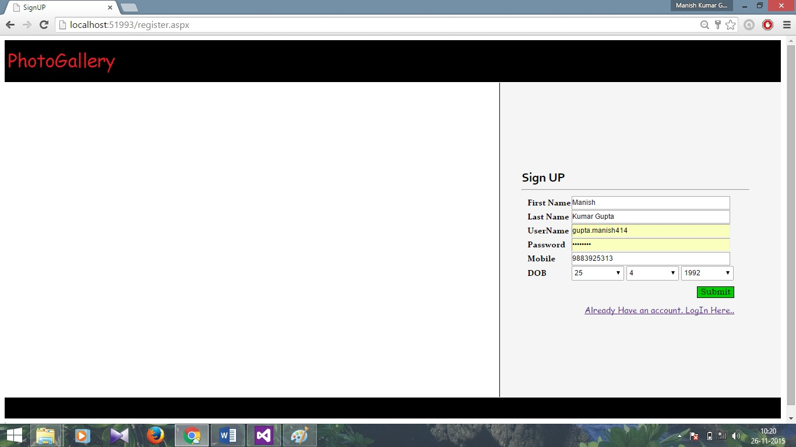

**(B)**Login Page

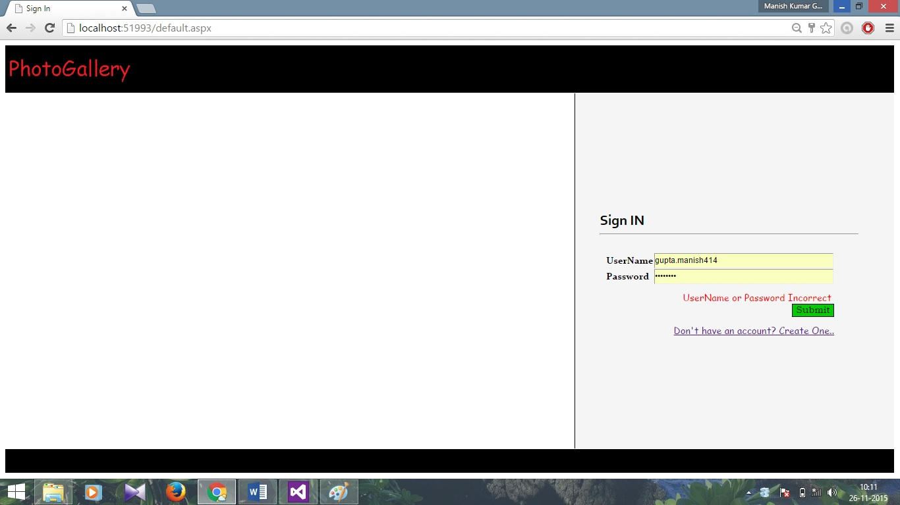

**(C)Home Page**

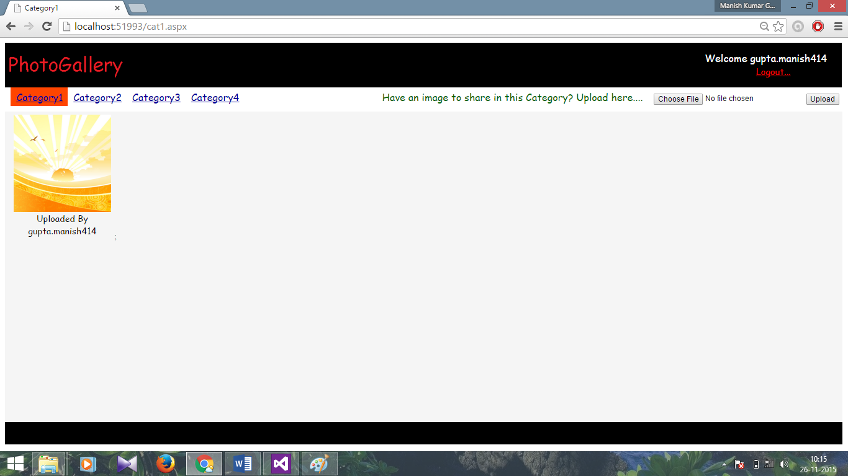

**(D)**UserLogin Database

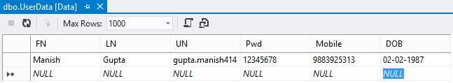

**(E)**Image Database

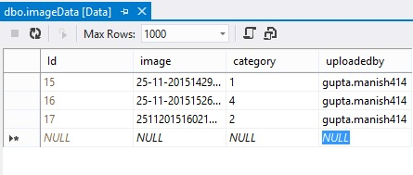

**CHAPTER: VI**

11. Conclusion

**(A)**Further Scope

As many large projects have some limitations my. The project might not met all the requirements of a real life application. But it could be further developed to increase its efficiency and variations.

**(B)**System Testing & Maintenance

As we all of known that software testing according to industry cannot be properly done in the student’s projects. But in spite of that factor I try to maintain the testing methodology in our project according to the software engineering aspects.

The entire project has been tested successfully by myself and our faculty member acting upon all the software engineering testing methodology.

Maintenance is such type of activity which much depends on the customer feedback. As our project is GUI (GRAPHICAL USER INTERFACE).If there are any difficulties or problems found in further in my project, I would be fully responsible and bound to be maintain the software at any time of customer reference.

**(C)**Enhancement Scope

The project might not met all the requirements of a real life application. But it could be further developed to increase its efficiency and variations. There is a scope to develop our project in future and increase its efficiency.

In our project Digit sort is proposed. It has complexity more than some earlier proposed algorithms, but we try to decrease its complexity. It has a special situation when its complexity will decrease with other sorting algorithm that is we try to focus in our project.

Further we try to develop a sorting algorithm that is better or effective as per as complexity concern and maintain the digit sort also.

**Conclusion**

From a proper analysis of positive points and constraints on the components, it can be safely concluded that the product is a highly efficient GUI based component. This application is working properly and meeting to all user requirements. This component can be easily plugged in many other systems.

Bibliography

**Website for Our Project:**

**1.** www.google.com

**2.** www.wikipedia.com

**3.** www.w3school.com